一开始是思考不定积分式子里的dx的必要性，后面发现不定积分符号用的是莱布尼兹的那一套，而在莱布尼兹的理论里无穷小量是核心，微分或原子无穷小量是核心（Leibniz had considered differentials as the fundamental concepts, the differential quotient being defined in terms of these; but Cauchy reversed this relationship；；；；；The derivative would in this case be defined as the quotient of two such differentials, and the integral would then be the sum of a number (perhaps finite, perhaps infinite) of such differentials），在不定积分式子里的f(x)dx在莱布尼兹看来就是底为长度原子单位的的矩形的面积，∫在他看来是Sum的意思，所以不定积分符号在他看来就是多个底为长度原子单位的的矩形的面积的和，而这个和就是变动的面积函数
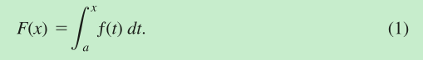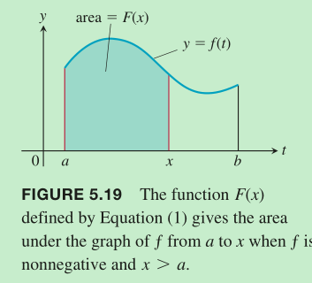
这样的话就想得通不定积分式子的含义了，否则的话容易这么想到
